Wordpress task 2

Q1. // ** MySQL settings - You can get this info from your web host ** //

/** The name of the database for WordPress */

define('DB_NAME', 's3660962');

/** MySQL database username */

define('DB_USER', 's3660962');

/** MySQL database password */

define('DB_PASSWORD', 'PRfs7r8t');

/** MySQL hostname */

define('DB_HOST', 'mysql.cs.rmit.edu.au:4022');

Q2.

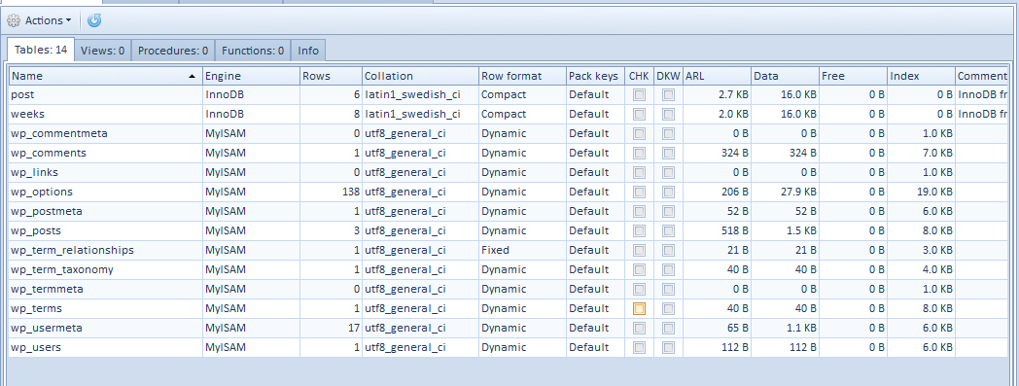

Q3. 3 folders, plugins and themes folder is inside wordpress, 1 plugin

Q4. In the folder

Q5. Nothing changes

Q6. Completed and ticked off

Q7. Done

Q8. Done

Q9. Done

Q10. Done

Q11. Done

Q12.